(Approx. 385 words)

Toshiba Laptop Display Replacement
By Scott Savary, Member, The PC Users Group-CT
September 2017 issue, The Program
www.tpcug-ct.org
merdoon (at) sbcglobal.net

Our Toshiba laptop developed a black spot on the lower right-hand corner of the screen. As time passed it grew and grew until we had to decide as to whether we wanted to replace the screen or the computer.

Since my wife really likes this computer I decided to replace the screen.

I copied down the product information from the tag and did a search on the internet for a replacement display. I was lucky and found a direct replacement for less than $50.

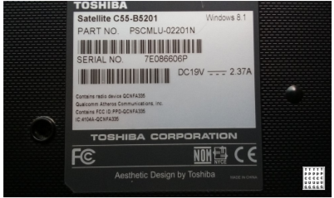

I then started looking for information on how to accomplish the swap out of the display. There was no exact video or written directions for this model. So, I watched several videos on similar laptops and took a deep breath and dove in.

Please remove the battery as a precaution prior to disassembly.

You have no screws holding the bezel onto the lid (see the photo below).

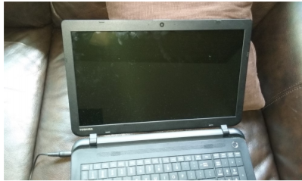

You gently pry it off from the screen side and work your way all the way around. I could do this using my fingers.

Quite simple really.

Two screws hold the frame surrounding the display to the upper lid. There were then six small screws holding the display to the frame and they came out easily. They are very short, so I advise using a magnetic screwdriver if you have one.

The next step is the trickiest. You have to remove the tape holding the cable into the connector on the back of the display. The tape is very sticky and you have to take your time to lift it off without damaging the video cable. To make things more interesting the camera cable is part of the video cable but you do not disconnect it.

The connector on the display does not have any latch; the tape holds it in place. After I reconnected the cable I installed the battery and turned on the laptop to be sure I had a solid connection. Thankfully, everything worked the first time.

Mount the display to the frame using the six small screws and then attach the frame to the lid. Gently snap the bezel back on to the lid and the project is done.

